A Rule-Based Expert System for Post-War Building Assessment in Gaza

Walid K. W. Alsafadi

University College of Applied Sciences

Expert Systems DSAI 3302

Dr. Mohammed A. Altahrawi

January 5, 2025

A Rule-Based Expert System for Post-War Building Assessment in Gaza

The aftermath of conflicts leaves behind widespread destruction, particularly in urban areas where buildings suffer significant structural damage. In Gaza, where infrastructure has been severely impacted by prolonged conflict, effective assessment and prioritization of reconstruction efforts are essential. However, the challenges in post-war building assessments are immense, including limited access to reliable data, environmental hazards, and socioeconomic vulnerabilities. These issues necessitate innovative and efficient decision-support tools *(Olayanju et al., 2015; UNRWA, 2021)*.

This project presents a **rule-based expert system** designed to aid decision-makers in assessing post-war building conditions and prioritizing reconstruction actions. The system evaluates multiple factors, including **structural damage**, **environmental risks**, **social impacts**, and **utility conditions**, while integrating **combined rules** to address scenarios involving multiple overlapping factors *(MDPI, 2022; Silva & Kernohan, 2016)*. By leveraging confidence levels, priority scales, and fuzzy logic, the system manages uncertainty and provides actionable recommendations *(ICRP, 2007; WHO, 2021)*.

To ensure usability, the system includes a **Streamlit-based user interface** (UI) that enables stakeholders to input building conditions and view prioritized recommendations in real-time. Deployed online, the tool serves as a scalable and accessible solution for engineers and policymakers working in Gaza and similar post-conflict zones *(Braun et al., 2018; USGS, 2013)*.

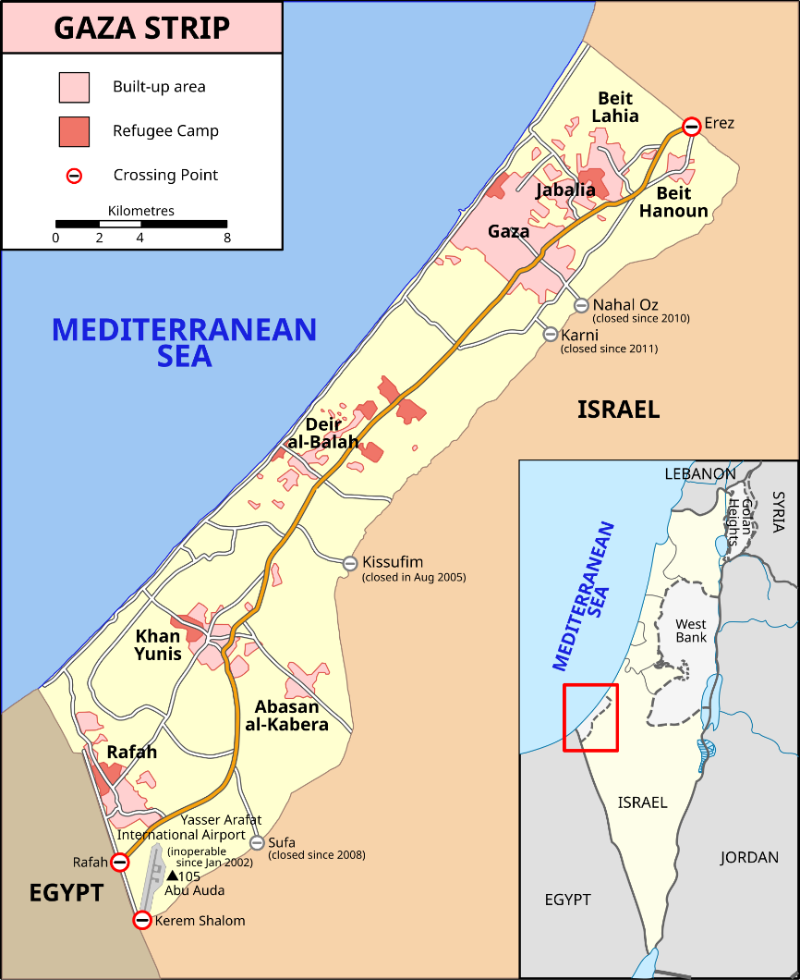

Figure1: Map of Gaza Strip showing built-up areas, refugee camps, and key locations (Source: Wikimedia Commons).

# Study Area

The Gaza Strip, located on the eastern Mediterranean coast, is a densely populated area of approximately 365 square kilometers. It is home to over two million people, making it one of the most densely populated regions in the world (UNRWA, 2021). The map of Gaza (Figure 1) illustrates its geography, refugee camps, and major cities, such as Gaza City, Khan Younis, and Rafah, along with crossing points to Israel and Egypt. This compact and enclosed region has faced decades of conflict, leading to significant challenges in urban planning and post-war rebuilding.

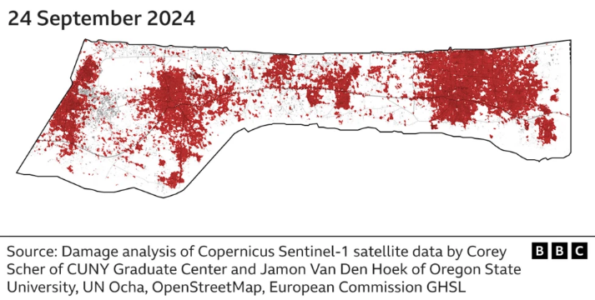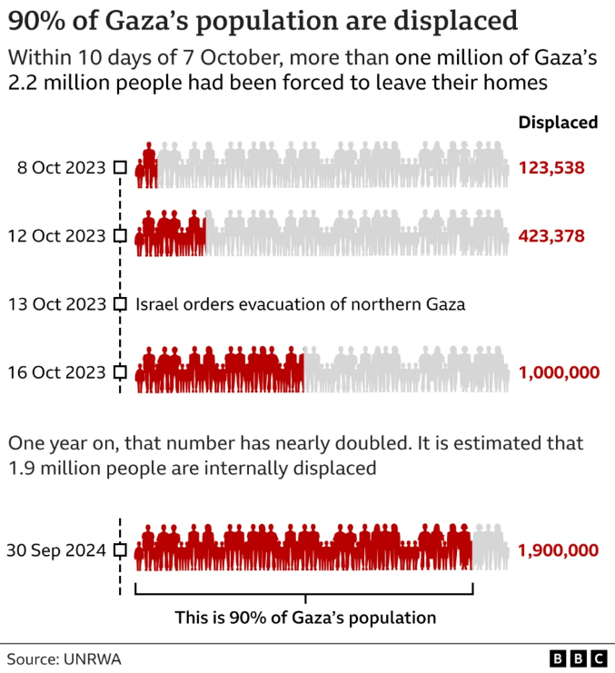

Figure2: Satellite analysis of damage in Gaza from Sentinel-1 data, highlighting the scale of destruction (Source: BBC).

Figure3: Displacement trends in Gaza, showing 90% of the population displaced over time (Source: BBC).

**Structural and Demographic Impact**

The region's infrastructure has been severely damaged due to recurrent hostilities, leaving vast areas in need of reconstruction. A satellite-based damage analysis conducted in September 2024 (Figure 2) highlights the scale of destruction, where red areas indicate heavily damaged or destroyed buildings. This analysis underscores the urgent need for systematic reconstruction prioritization to allocate resources efficiently.

Additionally, Gaza’s social fabric has been heavily impacted by displacement. Over 90% of its population has experienced displacement due to the destruction of homes and essential infrastructure. Figure 3 illustrates the timeline of displacement events during recent hostilities, culminating in an estimated 1.9 million internally displaced persons as of September 2024 (UNRWA, 2024). The graph emphasizes the ongoing housing crisis and the critical need for sustainable rebuilding efforts to accommodate displaced families.

**Challenges in Rebuilding**

Key challenges in post-war rebuilding include:

1. **Environmental Hazards**:
   * Flood-prone areas and coastal erosion pose significant risks to vulnerable structures (USGS, 2013; FEMA, 2013).
   * Seismic activity adds further complications to building resilience (ICRP, 2007).
2. **Structural Issues**:
   * Many buildings exhibit severe cracks, instability, and load-bearing wall failures (Braun et al., 2018).
3. **Social and Economic Factors**:
   * Overcrowding and inadequate access to temporary housing exacerbate rebuilding challenges (Silva & Kernohan, 2016).

These challenges necessitate a structured approach to prioritizing reconstruction efforts. The Gaza Strip serves as an ideal study area for evaluating the effectiveness of rule-based expert systems in managing post-conflict rebuilding initiatives.

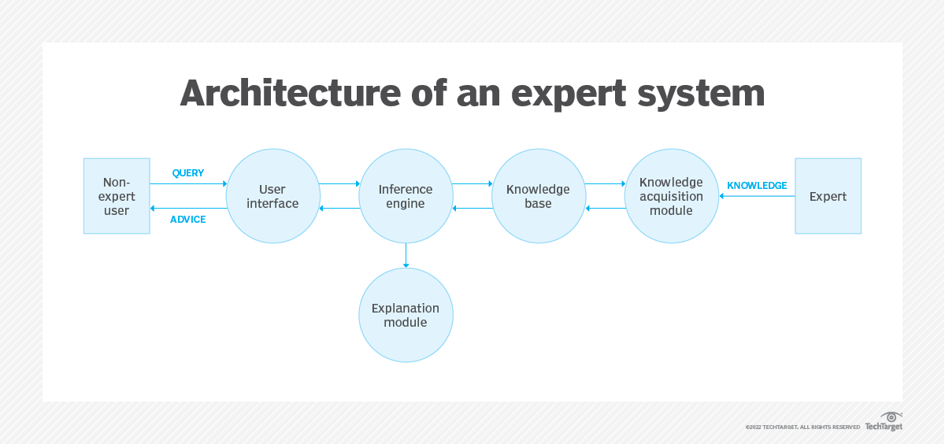

Figure4: Architecture of an expert system illustrating the interaction between the user interface, inference engine, knowledge base, explanation module, and knowledge acquisition module (TechTarget, 2022).

**Expert System Overview**

A rule-based expert system is a computational framework that emulates human reasoning by applying a knowledge base of rules to a set of facts. These systems are highly effective in structured environments requiring logical and consistent decision-making. This project utilizes a rule-based expert system to address the complex challenges of post-war reconstruction in the Gaza Strip, providing an efficient and transparent framework for prioritizing reconstruction efforts.

**Key Features of the Expert System**

The architecture of the expert system (Figure 4) comprises several critical components that ensure effective decision-making:

1. **Knowledge Base**:
   * The system is built on a foundation of 43 rules, systematically categorized into six domains: structural, environmental, social, utility & infrastructure, data & assessment, and design & sustainability.
   * Each rule is informed by domain-specific thresholds and international standards, including references from FEMA (2013), USGS (2013), and MDPI (2022), ensuring robust and credible assessments.
2. **Inference Engine**:
   * A forward-chaining inference mechanism evaluates input facts, triggers relevant rules, and prioritizes actions based on severity and confidence levels.
   * Combined rules are incorporated to account for interdependencies between multiple factors, such as the interplay between structural damage, environmental risks, and social vulnerabilities.
3. **Uncertainty Handling**:
   * The system employs confidence levels and fuzzy logic to address uncertainty in data inputs and recommendations.
   * For instance, cracks are classified into categories (minor, moderate, or severe) based on structural engineering thresholds, as demonstrated by Braun et al. (2018), enhancing the accuracy and reliability of assessments.
4. **User Interface**:
   * A user-friendly web interface, developed using Streamlit, allows decision-makers to input data and visualize recommendations in real time.
   * The interface is dynamic and interactive, enabling stakeholders to simulate various scenarios and explore the system's recommendations for actionable insights.

**Figure Integration**

As illustrated in **Figure 4**, the architecture of the expert system follows a modular design:

* **User Interface**: Facilitates interaction between users and the system by collecting queries and presenting actionable advice.
* **Inference Engine**: Serves as the decision-making core, applying rules from the knowledge base to input facts.
* **Knowledge Base**: Stores the system's rules and domain-specific thresholds.
* **Explanation Module**: Provides reasoning behind the system's recommendations, enhancing transparency.
* **Knowledge Acquisition Module**: Allows updates to the knowledge base, ensuring adaptability to evolving scenarios.

**Purpose**

The primary objective of the expert system is to streamline decision-making processes for post-war reconstruction in Gaza. By leveraging rule-based logic, it provides a consistent, scalable, and adaptable tool to prioritize repair and rebuilding efforts. This ensures transparency and efficiency in addressing Gaza's multifaceted challenges, ultimately empowering engineers and policymakers with actionable insights tailored to the region's unique needs.

**Challenges and Limitations**

Developing the rule-based expert system for post-war building assessment in Gaza presented a variety of challenges:

**1. Identifying and Validating Rules**

* Finding appropriate rules with references was time-consuming and required consulting multiple resources, such as structural engineering standards, environmental hazard guidelines, and social vulnerability data.
* Establishing thresholds, such as seismic risk levels and flood zone proximity, required significant research to ensure accuracy and relevance (USGS, 2013; FEMA, 2013).

**2. Deployment and System Compatibility**

* Deploying the Streamlit application with the original Experta library introduced compatibility issues. Integrating the inference engine with the user interface required additional debugging and adjustments.

**3. Maintenance and Scalability of Rules**

* Managing the 43 rules in the system was a challenge, especially when updating or adding new rules. Combined rules and dependencies further complicated this process.
* Testing each rule's behavior under different scenarios demanded a structured approach to ensure accuracy and consistency.

**4. Debugging and Testing**

* Debugging the system was challenging, as it required validating every possible input combination. This process was time-intensive, particularly for combined rules like "Radiation and cracks in hazardous zones."

**5. Integrating Fuzzy Logic**

* Converting some rules to fuzzy logic introduced additional complexity. Designing membership functions (e.g., for crack severity) and ensuring correct behavior required extensive fine-tuning.

**6. Limited Resources**

* Testing and debugging were resource-intensive due to the need for iterative validations. The lack of advanced debugging tools specific to rule-based systems made this process more laborious.

**Conclusion**

The development of this rule-based expert system for post-war building assessment in Gaza highlights the potential of combining knowledge-based methodologies with advanced computational tools to address the multifaceted challenges of disaster recovery. By integrating structural, environmental, social, and economic considerations into a single decision-support framework, the system provides a robust and scalable approach to prioritizing reconstruction efforts.

**Key Contributions:**

1. **Comprehensive Assessment**: The system leverages 43 rules spanning multiple domains, enabling a holistic evaluation of building conditions.
2. **Innovative Approaches**:
   * **Combined Rules**: Effectively handle interdependencies, such as hazardous zones exacerbating structural vulnerabilities.
   * **Fuzzy Logic**: Mitigates uncertainty in input data and provides nuanced recommendations.
   * **User-Friendly Interface**: A Streamlit-based platform ensures accessibility and transparency for engineers and policymakers.
3. **Practical Application**: Deployed as an online tool, the system is tailored to the unique challenges of Gaza, offering actionable insights for prioritizing reconstruction.

**Lessons Learned**

The project overcame significant challenges, including:

* Scaling the rule base to accommodate complex scenarios.
* Debugging and testing interdependent rules to ensure accuracy.
* Implementing fuzzy logic principles to address data uncertainty.

These challenges were addressed through iterative testing, collaboration with domain experts, and reliance on well-researched thresholds and guidelines.

**Future Directions**

While this project achieved its primary objectives, several opportunities exist for further enhancement:

1. **Rule Base Expansion**: Incorporating additional rules to cover more diverse scenarios and factors.
2. **Integration of Machine Learning**: Adding predictive models to complement rule-based logic and improve decision-making.
3. **Efficiency Improvements**: Optimizing the inference engine and system architecture for faster processing and scalability.

By addressing these areas, the system can evolve into an even more powerful tool for disaster management and reconstruction efforts, not only in Gaza but in other conflict-affected regions facing similar challenges.

**References**

1. Braun, A., et al. (2018). *Assessment of Building Damage Using Radar Satellite Imagery*. *Frontiers in Built Environment*. Available at: <https://www.frontiersin.org/journals/built-environment/articles/10.3389/fbuil.2018.00072/full>
2. MDPI. (2022). *Remote Sensing for Damage Assessment*. *MDPI Journals*. Available at: <https://www.mdpi.com/2072-4292/14/24/6239>
3. Tortorici, A., & Fiorito, R. (2017). *War Damage and Reconstruction Strategies*. *ScienceDirect*. Available at: <https://www.sciencedirect.com/science/article/pii/S1877705817317769>
4. International Atomic Energy Agency (IAEA). (2021). *Radiation Safety Standards for Materials*. Available at: <https://www.iaea.org/>
5. United Nations Relief and Works Agency (UNRWA). (2021). *Gaza Poverty Line and Economic Conditions*. Available at: <https://www.unrwa.org/>
6. Silva, J., & Kernohan, D. (2016). *Quality and Standards in Post-Disaster Shelter*. *ResearchGate*. Available at: <https://www.researchgate.net/publication/265077858_Quality_and_standards_in_post-disaster_shelter>
7. Asian Development Bank (ADB). (2015). *Enhancing Post-Disaster Recovery by Optimal Infrastructure Capacity Building*. Available at: <https://www.adb.org/sites/default/files/publication/182652/sdwp-041.pdf>
8. Federal Emergency Management Agency (FEMA). (2013). *Flood Mapping Guidelines*. Available at: <https://www.fema.gov/>
9. United States Geological Survey (USGS). (2013). *Engineering Geophysical Investigation of a Flood Zone*. Available at: <https://pubs.usgs.gov/circ/1544/cir1544.pdf>
10. World Nuclear Association. *Radiation Dose Examples*. Available at: <https://www.world-nuclear.org/>
11. World Health Organization (WHO). (2021). *Radiation and Health*. Available at: <https://www.who.int/news-room/fact-sheets/detail/radiation-and-health>
12. Hurricane Sandy Rebuilding Strategy. (2013). *Circle of Blue*. Available at: <https://www.circleofblue.org/wp-content/uploads/2013/08/Hurricane-Sandy-Rebuilding-Strategy.pdf>
13. Geotechnical Engineering Guidelines. FEMA. (2013). Available at: <https://www.fema.gov/>
14. *Post-Earthquake Damage Assessment*. (2018). *Frontiers in Built Environment*. Available at: <https://www.frontiersin.org/journals/built-environment/articles/10.3389/fbuil.2018.00072/full>
15. Copernicus Sentinel-1 Satellite Data. European Space Agency. Available at: <https://www.esa.int/>
16. BBC. (2024). *Gaza Post-Conflict Satellite Analysis*. Available at: <https://www.bbc.com/news/world-middle-east-67241290>
17. Wikipedia contributors. (2024). *Map of the Gaza Strip*. Retrieved from <https://upload.wikimedia.org/wikipedia/commons/thumb/9/93/Gaza_Strip_map2.svg/1672px-Gaza_Strip_map2.svg.png>
18. TechTarget. (2022). *Architecture of an Expert System*. Retrieved from <https://www.techtarget.com/searchenterpriseai/definition/expert-system>